/*------------------------------------------------------------------------------------------*/

/*Select statements*/

select id, state, ethnicity

from student

where income >= 100000;

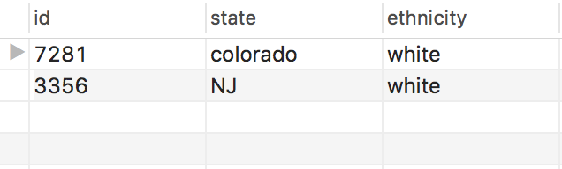

select id, major

from student

where application = 'ED1';

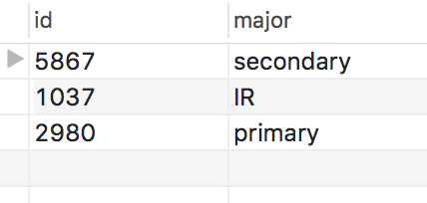

select id, application

from student

where income >= 50000;

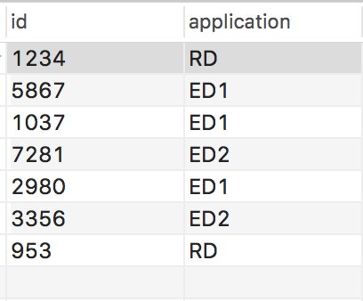

select id, state, ethnicity

from student

where income < 80000;

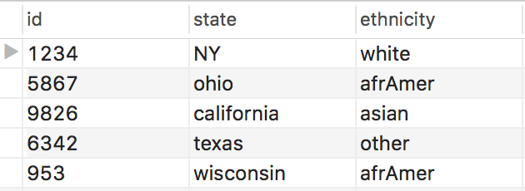

select school.school, student.major, income

from school, student

where school.major = student.major

and income < 100000;

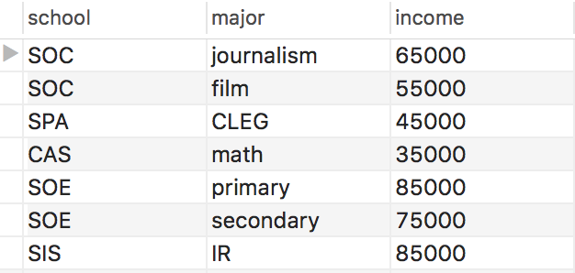

select id, income from student

order by income asc;

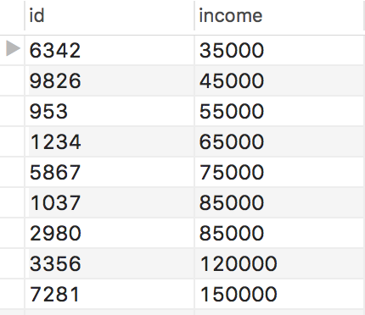

select school.school, student.major

from school, student

where school.major = student.major

order by school;

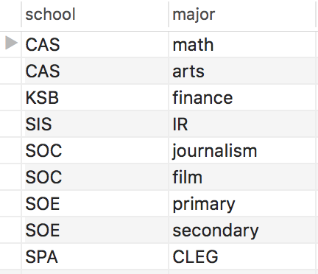

select id, state, income

from student

where state in

(select state

from region

where area = 'midWest');

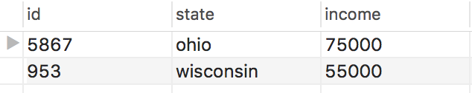

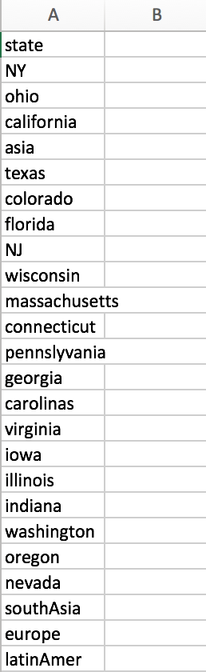/*------------------------------------------------------------------------------------------*/

/*union operation*/

select state

from student

union

select state

from region;

/*------------------------------------------------------------------------------------------*/

/*insert a set of tuples (by using another select statement)*/

insert into student(state)

select 'westCoast' from region where state = 'california';

select * from student;

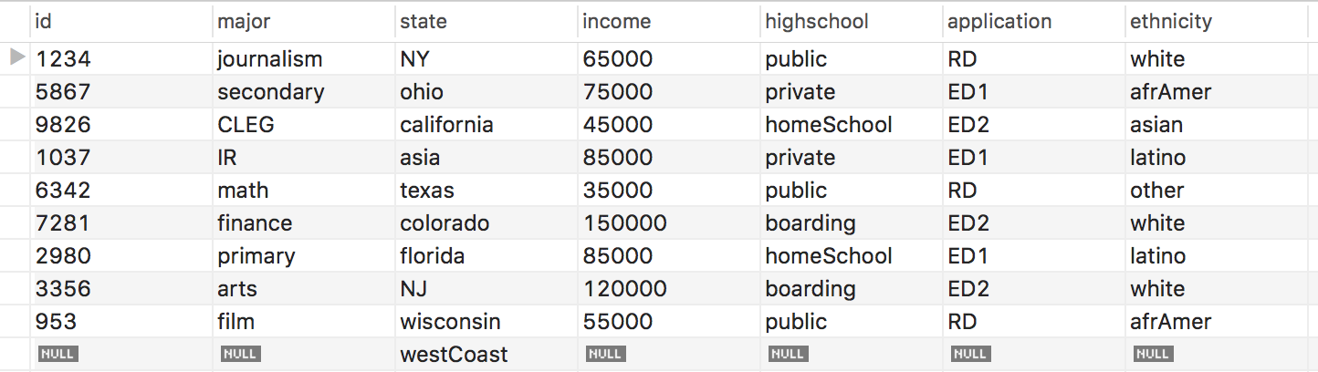

/*------------------------------------------------------------------------------------------*/

/*Update queries*/

alter table student

add stuName varchar(255);

update student

set stuName = 'Lauren London'

where id = 1234;

update student

set stuName = 'Grayson York'

where id = 5867;

update student

set stuName = 'LeeAnn Colbert'

where id = 9826;

update student

set stuName = 'Billy Tifft'

where id = 1037;

update student

set stuName = 'Marci Glass'

where id = 6342;

update student

set stuName = 'Denis Winton'

where id = 7281;

update student

set stuName = 'Helena Linton'

where id = 2980;

update student

set stuName = 'Dorris Peterson'

where id = 3356;

update student

set stuName = 'Frank Chambers'

where id = 0953;

select * from student;

/*See “updated_student_table” for results */

/*------------------------------------------------------------------------------------------*/

/*insert involving two tables*/

insert into student values(7865, 'compSci', 'georgia', 42000, 'public', 'ED2', 'other', 'Rebecca Saga');

insert into school values('CAS', 'compSci');



/*------------------------------------------------------------------------------------------*/

/*Delete statements*/

delete from region where state = 'iowa';

select * from region;

/*see tables for updated result*/

/*------------------------------------------------------------------------------------------*/

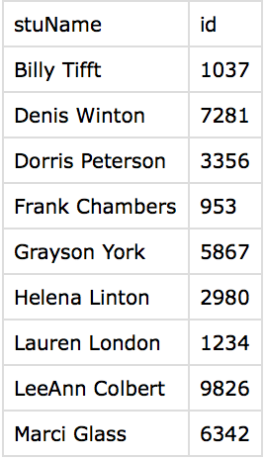/*Create View*/

create view StuNameID as

select stuName, id

from student

order by stuName;

select * from StuNameID;

/*------------------------------------------------------------------------------------------*/

/*Triggers*/

Delimiter $$

create trigger region_income_insert after insert on student

for each row

begin

delete from region;

insert region

select state, income from student

order by income;

end;

$$

Delimiter $$

create trigger major_delete after delete on school

for each row

begin

delete from school where major=old.major;

end;

$$

Delimiter $$

create trigger addstate before insert on

region

for each row

begin

declare temp Int;

set temp=0;

select count(*) into temp from region

where state=new.state;

if temp=0 then

insert into Mylog values(concat('state ',new.state, ' is

not in the system'));

insert into anytable values('Just to cause error');

end if;

end;

$$

Delimiter $$

Create trigger major_checking before insert on

school

For each row

Begin

Declare temp int; set temp=0;

Select count(*) into temp

From school where major=new.major;

If temp=0 then

Insert into mylog values('Invalid Major');

Insert into anytable values('This major is not offered');

End if;

End;

$$